Design Documents Deliverable

7/5/2021

Group Five

High Level Architecture

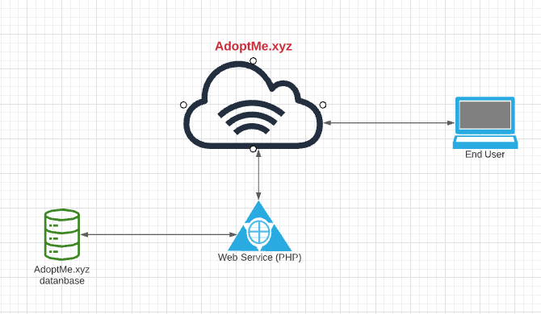

Class Diagram

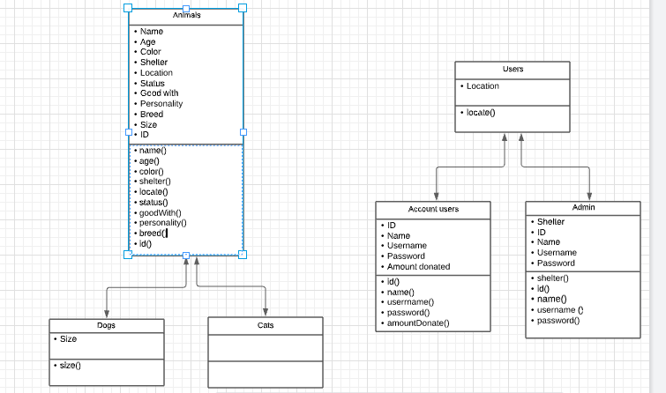

Interface Spec

|  |
| --- |
| <<Interface>>  Cat |
| * name(ID): string * age(ID): string * color(ID): string * shelter(ID): string * locate(ID): string * status(ID): string * goodWith(ID):string * personality(ID):string * breed(ID): string * set(ID, dataField) |

|  |
| --- |
| <<Interface>>  Dog |
| * name(ID): string * age(ID): string * color(ID): string * shelter(ID): string * locate(ID): string * status(ID): string * goodWith(ID):string * personality(ID):string * breed(ID): string * size(ID): string * set(ID, dataField) |